Name: ___________________________________________ Date: ______________________

Unit 2 Lesson 1 HW – Polynomials Alg2CC – Visca

**Write each polynomial in standard form, then identify its degree**

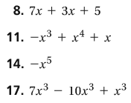





**Simplify each expression then state the most solutions it can have.**



